Modeling musical data

Musical works are complex objects. Expressing them comprehensively requires the description of (1) their physical manifestations (recordings, scores…) and (2) all the events that define them (creation, publication, performance…). The first aspect is relatively well mastered nowadays, in library catalogues as well as in the musical industry. Several models can be used to describe it. Some are specific to music (MusicOntology), others are more generalist (FRBR[1], UNIMARC[2]…). The second aspect is rather new, although there is a growing need and interest in it. Several ontologies specifically define events (Event[3], DOLCE[4], etc.), but there are few examples of them being used to describe processes of creation or publication. One of the difficulties with musical works is that although their expressions may differ significantly they are still regarded as a single Work. Modeling them requires to express the unity of the Work and the specificities of its expressions, and to show how events are connected to these expressions. In some cases an arrangement may also be considered as a new Work (criteria vary among agencies), so a model shall also make it possible to describe the link between Works when one Work is derivated from another.

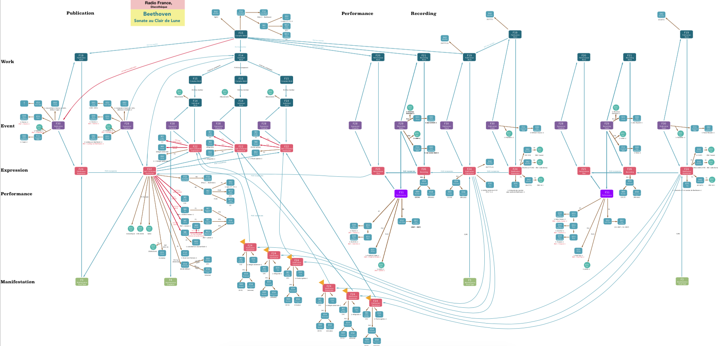

Fig 1. Modelisation of a simple Work

Our goal in DOREMUS is to find a model enabling the expression of all these aspects in a coherent way, while being flexible and powerful enough to interoperate with information systems dealing with generalist data. It occurred to us that FRBRoo[5] had all the required qualities. It is based on FRBR and CIDOC-CRM[6] models, with a concern for the necessity to describe how Events occur through the life of a Thing and the resulting states of this Thing. It is (1) a generalist model, (2) based on the articulation of Events and Things, (3) containing the notion of Work, (4) and offering precise elements to describe physical items. In addition, (5) itt has fine granularity and an adaptable structure. However, since the Work as defined in this model is not specifically musical, we decided to extend the model, adding a few Classes and Properties that are recurrent and important in the description of a musical work.

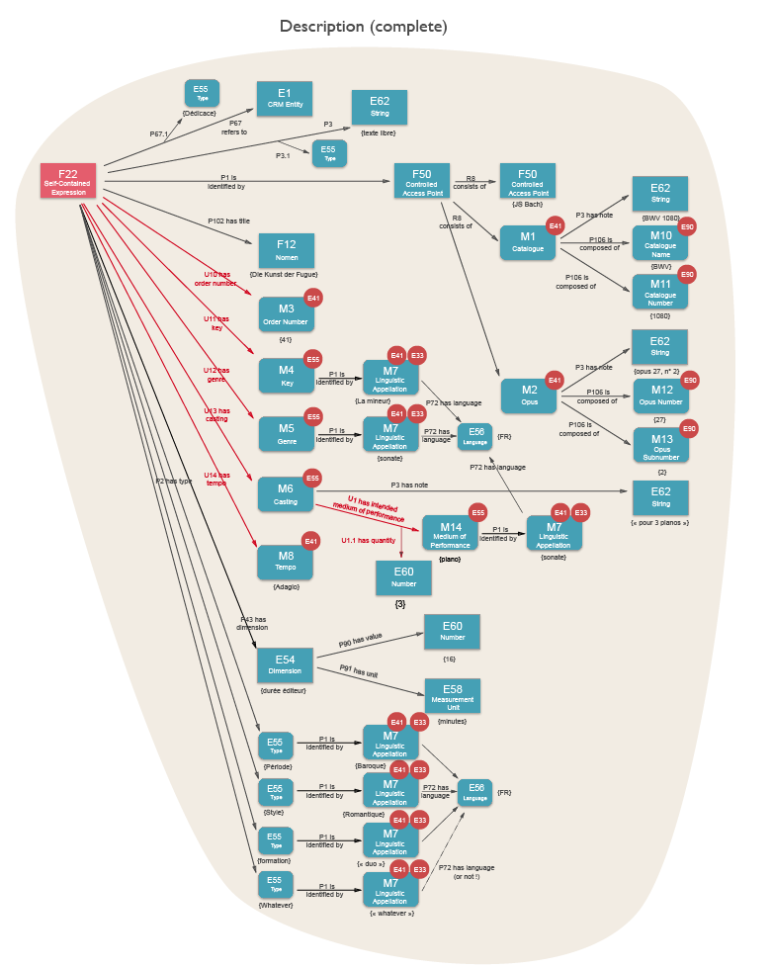

Fig2. New classes are named *M1, M2… Mn* and new properties *U1, U2, … Un*

We restricted the perimeter of our research to classical music and traditionnal music, which we regarded as representative of the scale of concerns musical works can offer. The roadmap starts with a simple work (both figures above apply to this category), before considering vocal works, works performed on stage, and then eventually traditionnal music.

We used data from our 3 institutions as a base, keeping in mind probable evolutions of our databases and potential needs of future users. We wrote a few theoretical ideal examples as guidelines for future users, and mapped our own data with the model : in a spreadsheet listing each feature of the model, we indicated if we were able to fill in data, and if so which transfer rules would be applied.

1. http://www.ifla.org/publications/functional-requirements-for-bibliographic-records
2. http://www.ifla.org/publications/unimarc-formats-and-related-documentation
3. http://motools.sourceforge.net/event/event.html
4. http://www.loa.istc.cnr.it/old/DOLCE.html
5. http://www.cidoc-crm.org/frbr_drafts.html
6. http://www.cidoc-crm.org/official_release_cidoc.html